Terminate an Employee

From an employee’s Related Actions:

1. Select **Job Change** > **Terminate Employee** to display the Terminate Employee page. 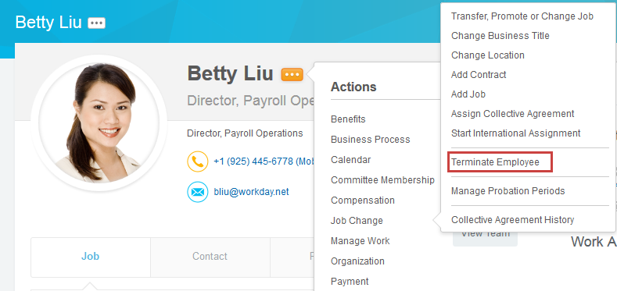
2. Complete the required termination information. Here, you will enter a termination date and reason. The employee is still considered active until midnight of the termination date.
3. Indicate whether the position is to be closed or available for overlap after this termination. Position overlap allows a replacement worker to be hired into the same position before the current worker leaves.

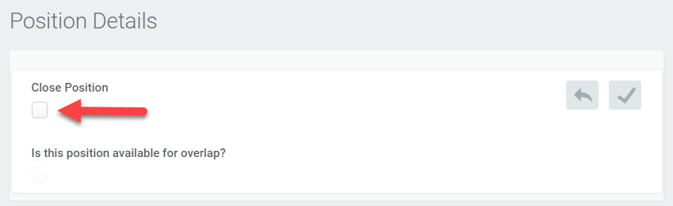

1. Click **Submit** and then it will be set through the appropriate approval process
2. If the position is left open this will kick off the open req process for recruiting.

View Open Positions in Your Organization

From the Employee Changes worklet:

1. Click the **Open Positions** button in the View section.
2. Choose your Organization. If you want to view all subordinate positions instead, mark the **Include Subordinate Organizations** checkbox.

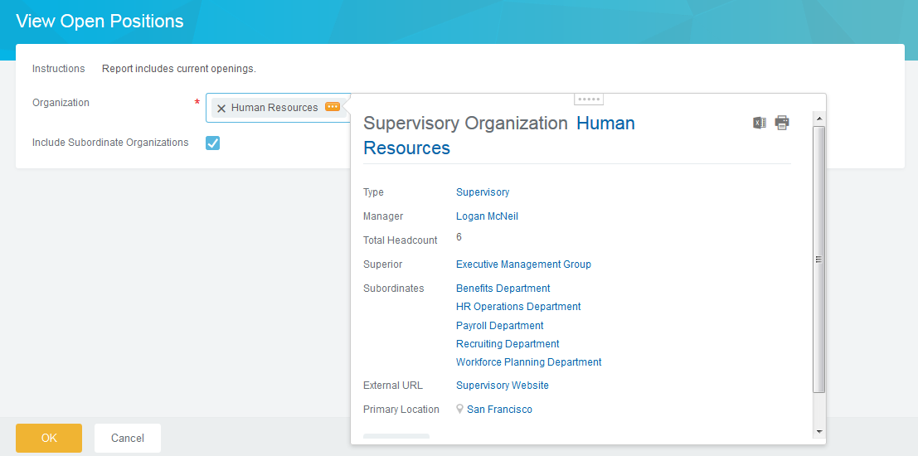

1. Click **OK** to run the report.